Golidlocks and the three fears

David Leitch

2024-06-10

# Goldilocks and the three fears

Are you tucked in kids? nice and comfy? You want a story? Which one? Oh you like the ones daddy makes up do you? Well I haven’t got time tonight but here is an old story that I might remembered wrongly…

Once upon a time the wonderful world we live in was threatened by a great invisible problem. Concentrations of atmostpheric carbon built up and up sending gauges deep into the red and setting in place processes that would continue for a century. After much hand wringing and many, many checks of the dials and guages to make sure it was as bad as it looked a call for help went out.

The bright engineering people who love nothing better than a challenge and who wanted to leave the world in good shape had a wonderful idea. What if they could go into the woods and build lots of wind and solar farms and batteries to replace the coal mines and the coal fired powered stations. They thought that the world would be a better place and wasn’t it wonderful that instead of smelly noisy machines left over from the industrial revolution loading up the atmosphere with heat reflecting carbon, we could instead have wonderful, reliable electric power and in the process make regional areas the thriving growth hub of australia. That way all their children, grandchildren and future generations might have a chance at the good life that Australians have become so accustomed to over many years. A life built on the hardwork and sacrifice of their parents and grandparents and which so many around the world also aspired to.

Instead of all the young smart people moving from the country to the city, young professional families would move to the regions bringing increased levels of econcomic activity, enthusiasm and new life. Instead of country people being disadvantaged because there were lower quality hospitals, less internet, more expensive airfares, lots of crime in the towns instead of that regional centres even places like Dunedoo that noone had ever heard of before would become thriving centres of activity. Boarded up shops would find new tenants and so on.

Of course the conservative old men on the farms used to being the boss because they were the eldest sons and therefore quite literally born to rule, wouldn’t necessarily be happy. Well they aren’t called grumpy old men for no reason. They would be a bit scared and resist anything that threatened their position of dominance. In this they were normal, old people had always resisted change. Its just that there were so few people left with an interest in regional Australia, that noone bothered. You think houses are unaffordable in the city, try buying a farm. And then if you do, try running it.

So the enegineers and their friends with the chequebooks went out into the country and spoke the message and at first there was little interest. Many jokes from the local yokels were made about the dumb ones. Aftere a while though as more and more wind farms were built in South Australia there were less jokes and more talk about dangerous experiments. And indeed it was dangerous …. to coal fuelled power stations and several closed quickly. Quickly the mainstream press lead by those great forward thinkers at the AFR and the Australian heaped satire on South Australia calling it the great experient and imagining it would fail. But it didn’t. Soon Victoria was even bigger in renewable energy than South Australia and NSW and QLD looked over their shoulder into the future and decided to move quickly. And then not only wind but an insidious problem called solar became ever more stronger and soon it was impossible to control.

Now to many vested interests the growth and popularity of renewable energy wasn’t just dangerous it was potentially life threatening…. to coal generation, to thermal coal mining and perhaps to the Australian way of life. Who knew where things might end, even the gas and oil industry could be impacted. It was up to vested interests all over the world to act together and individually. Here in Australia the sunburned old white males put on costumes with big hats and baseball caps and used the “bush telegraph” to call for help. And tafter convocation they held pow wows with famous “spin doctors”. We do not know which doctors but typical friends of these people are Topham Guerin and Crosby Textor.

These spin doctors knew that the best way to undermine change is to work on people’s fears. Humans are scared of the unknown, shadows turn into giant trolls, small noises are amplified. In general amplifying the fears that people have about nearly everything is a very effective tactic.

So the people with nice clothes interviewed many subjects to identify their worries and developed strategies to amplify these concerns. And borrowing from the Chinese approach they told the old white men in charge of the “Three fears”. And with the three fears they developed a “dog whistle”. That’s because the men in charge know that anyone blowing the “dog whistle” would be seen and recognised as a “member of the group”. And the dog whistle was soon used on TV by say Innes Willox. For those listening the words of the dog whistle are.

“Affordable reliable power”

That dog whistle effectively embodies two of the fears that the spin doctors are amplifying. The fears are:

* Renewable energy is intermittent and therefore unreliable. The sun doesn’t shine and the wind doesn’t blow, we’ll be ruined;
* Renewable energy costs more than thermal energy. In fact it will cost too much and electricity prices will make Australia uncompetitive;
* It looks ugly and will ruin the environment, whales will die, birds will die, trees will die, everyone will go deaf and so on. People who think renewable energy is good for the environment are either evil or stupid or both. The reality is renewable energy is bad for the environment. Coal is good for the environment and gas is even better. Renewable energy uses up all the farming land and there is no room in Australia for any more wind or solar farms.

So dear children its time for lights out tonight. How Goldilocks sat down with the three fears and turned them into her best friends and how Australia went on to live happily ever after will have to wait for next time. Meanwhile when you are at school tomorrow keep your ears tuned for the “dog whistle” and when you hear it, tell your friends.

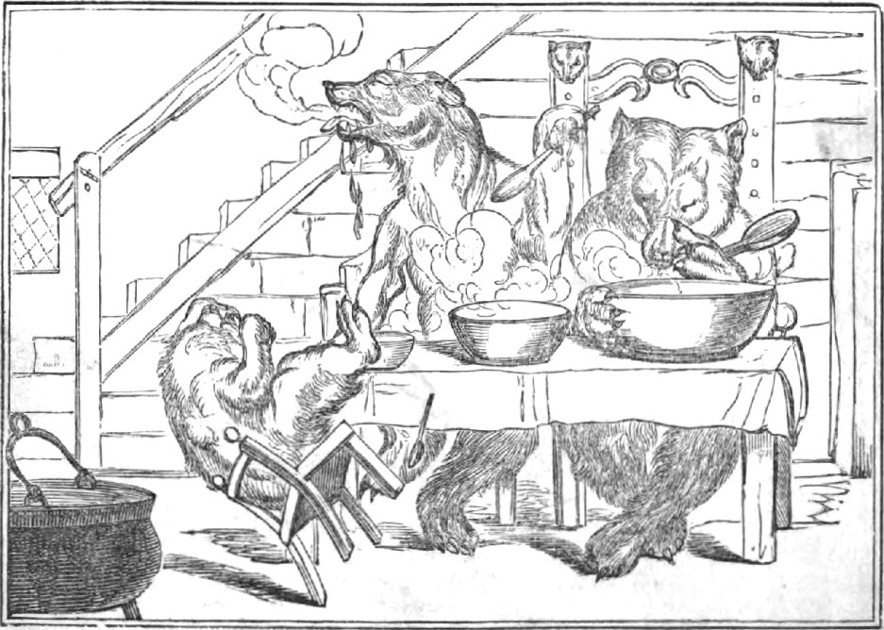

The three bears. Source: Wikipedia